Ideation Phase
Define the Problem Statements

Date | 29 January 2026
Team ID | LTVIP2026TMIDS85199
Project Name | AutoSage App Using Gemini Flash
Maximum Marks | 2 Marks

Customer Problem Statement:

People interested in purchasing or comparing two-wheelers and four-wheelers often struggle to access complete and reliable vehicle information from a single source. Important details such as manufacturer, model, mileage, key features, price range, and resale value are scattered across different platforms. Users are forced to manually search and analyze lengthy technical descriptions, which consumes time and creates confusion. Most existing solutions do not leverage image-based artificial intelligence to deliver quick and well-organized insights. As a result, users experience uncertainty and lack confidence while making vehicle-related decisions.
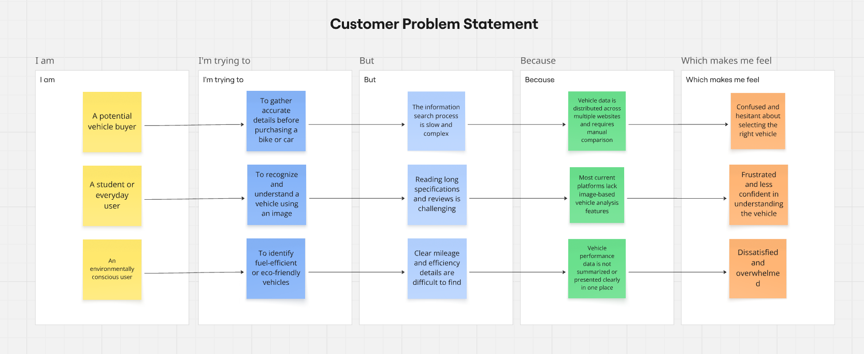

Link: https://miro.com/app/board/uXjVG_OZKgA=/?share_link_id=529701320551

Problem  Statement (PS) | I am  (Customer) | I’m trying to | But | Because | Which makes me feel
PS-1 | A potential vehicle buyer | To gather accurate details before purchasing a bike or car | The information search process is slow and complex | Vehicle data is distributed across multiple websites and requires manual comparison | Confused and hesitant about selecting the right vehicle
PS-2 | A student or everyday user | To recognize and understand a vehicle using an image | Reading long specifications and reviews is challenging | Most current platforms lack image-based vehicle analysis features | Frustrated and less confident in understanding the vehicle
PS-3 | An environmentally conscious user | To identify fuel-efficient or eco-friendly vehicles | Clear mileage and efficiency details are difficult to find | Vehicle performance data is not summarized or presented clearly in one place | Dissatisfied and overwhelmed

